10 Cleaner / Fines-Control Philosophy and CV09 Pilot
The findings at CV09 provide a practical opportunity to test an improved cleaner-and-containment approach because the existing cleaner arrangement, the active wet-material fallout, the surrounding fines accumulation and the intended destination of cleaner-removed material can all be related at the same location. Rather than treating CV09 only as an isolated maintenance problem, it can therefore be used as a pilot location to demonstrate whether improved belt cleaning and better containment of the removed fines can reduce both the local spillage condition and the amount of carryback progressing further downstream.
The proposed approach is based on a simple functional objective: remove residual fines before they enter the return run and keep the material removed by the cleaner within the existing discharge process. To achieve this, the cleaner should act while the belt is positively supported by the head pulley, with the cleaning stages positioned within the existing head/discharge-chute arrangement so that removed fines can fall naturally back into the combined-product discharge flow. The proposed cleaner arrangement should also incorporate a spring-loaded/self-tensioning mechanism that provides controlled wear compensation as the cleaner element wears. This helps maintain positive, controlled cleaner-to-belt contact through service and reduces reliance on repeated manual readjustment to compensate for normal wear. A two-stage cleaner arrangement is preferred where the verified site geometry allows it. Where practical constraints prevent two effective stages from being installed, one effective pulley-supported stage may be considered as the constrained minimum, subject to the final OEM/responsible-design assessment.

Conceptual arrangement
The proposed CV09 philosophy is illustrated by two complementary drawings:
CTD-005 / DRAW-005 — CV09 Preferred Primary / Secondary Cleaner Placement and Orientation
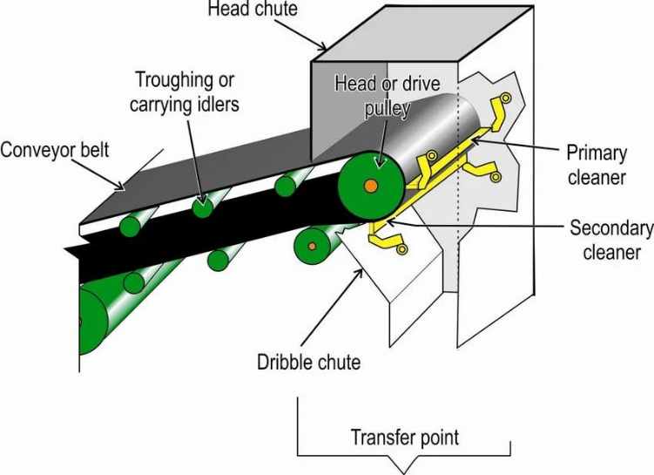
This figure illustrates the typical relationship and orientation of primary and secondary cleaner stages relative to the head pulley. Its purpose is to help explain where the cleaning action should take place while the belt remains positively supported. It is a placement/orientation reference and does not prescribe the final cleaner make, model or CV09 installation geometry.

Dust Control Handbook for Industrial Minerals Mining and Processing, RI 9689 (2012)

CTD-006 / DRAW-006 — CV09 Cleaners Inside Head-Chute Containment Principle
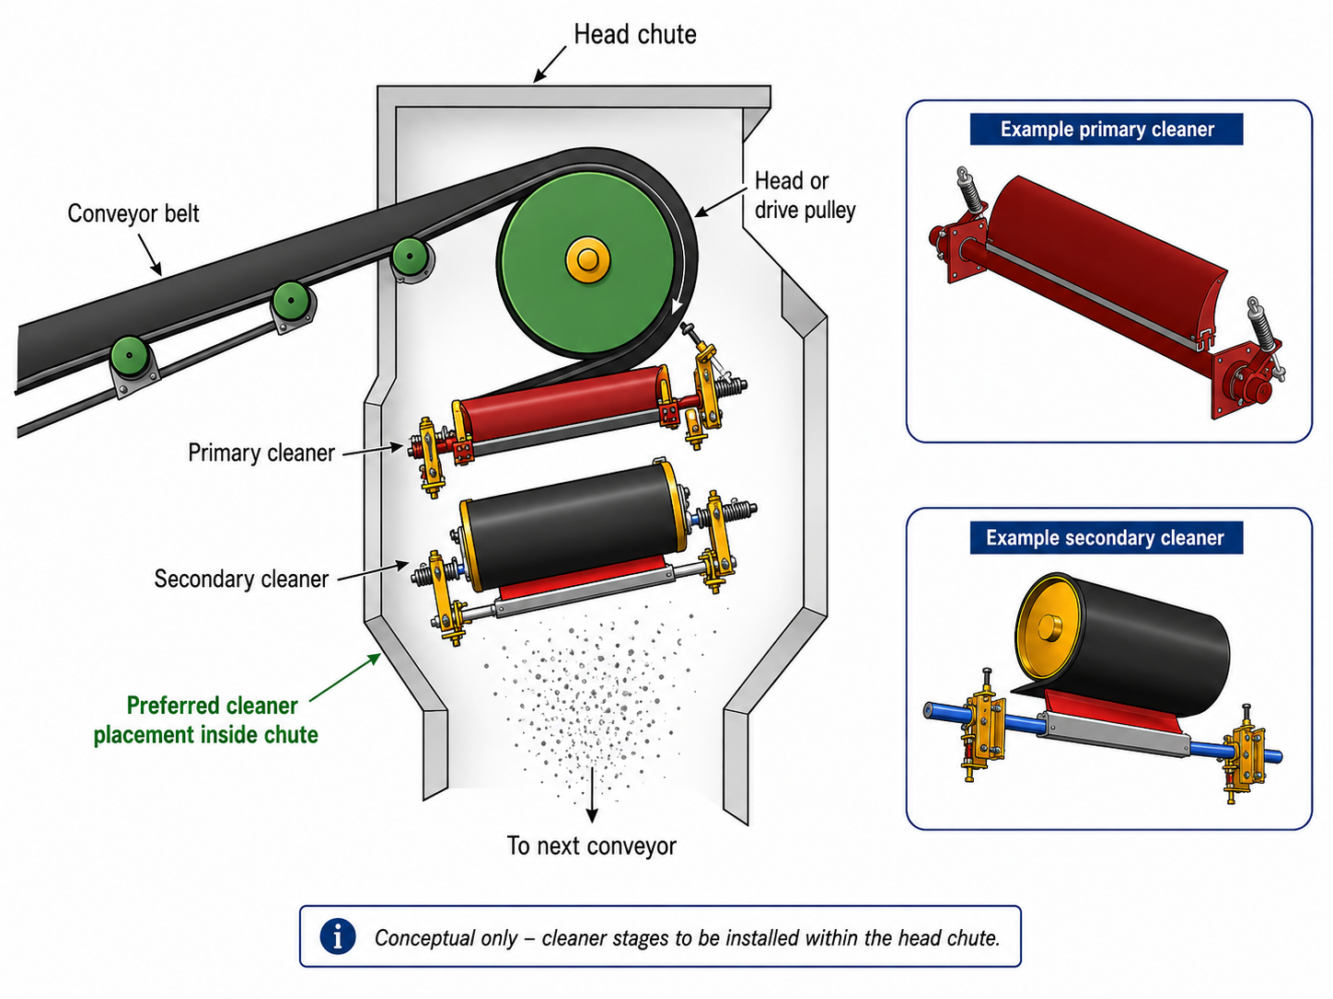This figure illustrates the complementary containment principle: the cleaner stages are positioned inside the head/discharge chute so that fines removed from the belt remain within the existing product flow rather than being discharged into the surrounding plant area.
The two drawings are therefore intended to be read together:
DRAW-005 explains where and how the cleaner stages act relative to the head pulley; DRAW-006 explains where those stages should sit relative to the chute so that the removed material remains inside the process.
The two drawings are intended to be read together. DRAW-005 is an external/reference placement illustration showing where and how the cleaner stages typically act relative to the head pulley. DRAW-006 is the project conceptual containment figure showing that the cleaner stages should sit within the head/discharge chute so that removed material remains inside the process. Neither drawing defines the final CV09 hardware or fabrication geometry; final dimensions, mounting arrangements, cleaner technology and site interfaces remain subject to verification and detailed design.
The drawings principally illustrate cleaner placement and containment. The spring-loaded/self-tensioning wear-compensation arrangement is an additional functional requirement of the proposed cleaner philosophy. Its purpose is to help maintain positive, controlled cleaner-to-belt contact as the cleaner element wears, while reducing reliance on repeated manual readjustment. The final spring arrangement, contact force, adjustment range and associated mechanical details remain subject to OEM/responsible detailed design.
Functional requirements for the pilot arrangement

The detailed CV09 design should be developed around the following functional requirements:

- Locate the cleaner contact where the belt is supported by the head pulley so that the belt remains mechanically stable through the cleaning zone.
- Provide effective cleaning across the required belt width while maintaining suitable cleaner-to-belt contact as the wear elements reduce through service.
- Provide a spring-loaded/self-tensioning wear-compensation mechanism that maintains positive, controlled cleaner-to-belt contact as the cleaner element wears through service. The arrangement should reduce the need for repeated manual adjustment while still allowing appropriate inspection and setting, and should include a positive mechanical travel/wear limit to prevent uncontrolled over-travel toward the belt.
- Keep the cleaner stages within the head/discharge-chute containment so that material removed from the belt falls naturally into the existing combined-product discharge flow rather than creating a separate fines-spillage point.
- Provide practical access for inspection, adjustment, cleaner-element replacement, guarding and clean-out.
- Confirm the final cleaner type, materials, contact arrangement, forces, supports, movement, structural attachments, dimensions and tolerances through the OEM/responsible detailed-design process.
STANDARDISE THE FUNCTION | The intention is not to install one identical scraper arrangement at every conveyor. The CV09 pilot should first demonstrate that the required cleaning-and-containment function can be achieved reliably at this location, including effective cleaning, spring-loaded/self-tensioning wear compensation, controlled cleaner-to-belt contact and retention of removed fines within the discharge process. Other applicable conveyors can then be assessed against the same functional requirements, while the actual cleaner hardware and installation arrangement are adapted to their own belt condition, chute geometry, operating duty, maintenance access and available installation space.  U4 remains a location-specific exception because its cleaner and discharge arrangement differs materially from the more conventional conveyor geometry considered for wider application.
.

Pilot verification
The value of the CV09 pilot should be judged by its performance over representative operation rather than simply by how clean the area appears immediately after installation. The as-found condition should first provide a practical baseline against which the modified arrangement can be compared.
Successful performance should demonstrate that downstream carryback is materially reduced relative to that baseline, cleaner-removed fines remain within the existing discharge process, and the spring-loaded/self-tensioning arrangement maintains effective cleaner-to-belt contact as the cleaner element wears without requiring excessive routine manual readjustment. The installation should also remain practical to inspect and maintain without introducing unacceptable belt wear, cleaner wear, material trapping, guarding conflicts or maintenance-access difficulties.
The resulting monitoring record should provide enough evidence to determine whether the same functional cleaner-and-containment philosophy is suitable for wider application at other conveyors, while still allowing each location to be designed around its own geometry and operating requirements.

